Math and Music

A dice game, attributed to Mozart, was written in 1787.

http://si.smugmug.com/Portfolio/Portfolio/piano/82084701_4iBkW-XL-1.jpg

Mozart wrote 300 measures for a minuet, and then assigned numbers to the measures. The idea is to roll a die or dice to determine which measure to insert. Each minuet is composed of 32 measures.

Your Task

Collect Data and Validate Sources
- Research the history and rules of this game.
- Justify the validity of your sources.
Analyze and Present Data
- Explore the mathematics of this dice game. Answer questions that interest you, showing your calculations. Sample questions might be (but do not limit yourself to these): How many minuets are possible? How long would it take to play them all? What is the probability of two people hearing the same minuet?
Present Multiple Sides
- Identify any controversies and present multiple sides of the issue with supporting data. Answer questions like (but not limited to): Is there any controversy about authorship of these minuets? Are they true minuets? Did anybody else ever write anything similar?
Present Research Project
- Present your project in a format approved by your teacher.

Misuse of Probability in Court

In 1964, an elderly woman was walking down an alley, on her way home from the store. She was pushed to the ground and robbed of her purse. The elderly woman saw a young woman with a blond ponytail running away. Farther down the street, a witness saw a woman run out of the alley and jump into a yellow car. The witness saw that the driver of the yellow car was a black man with a beard and mustache. The woman he saw was Caucasian with blond hair in a ponytail.

http://images.cdn.fotopedia.com/flickr-3932561335-hd.jpg

The police arrested Janet Collins and her husband Malcolm and charged them with the crime. Neither witness could positively identify the pair. The prosecutor used probability and concluded that the probability that a random couple had a man with a beard and a moustache, a woman with blond hair and a ponytail, was interracial, and owned a yellow car was 1 in 12 million. Based on these odds, the jury found the couple guilty. The couple appealed.

Your Task
Collect Data and Validate Sources
- Research this case, or any other that relied on probability to convict the alleged perpetrator.
- Justify the validity of your sources.
Analyze and Present Data
- Examine the initial probabilities presented in court, and then present any new calculations discussed at an appeal.
- Analyze the data you have collected and check the mathematics.
Present Multiple Sides
- Identify any controversies and present multiple sides of the issue with supporting data. Answer questions like (but not limited to): Whose mathematics was correct in the case you studied? Did the court get it right at the initial trial, or in the appeal? Why might one side present the data in a biased way? How prevalent is this practice?
Present Research Project
- Present your project in a format approved by your teacher.

Busting Vegas

In the 1990's a team of students from MIT in Cambridge, MA developed strategies to beat blackjack games in Las Vegas.

http://farm5.staticflickr.com/4007/4661886104_5cf6ae106c.jpg

Research the story of the MIT Blackjack team. Several books and movies have been made on the subject. Discuss their strategies, and examine how the strategies tipped the odds in their favor.

Your Task

Collect Data and Validate Sources
- Research this story.
- Collect numerical data that shows how this team changed the odds in their favour.
Analyze and Present Data
- Analyze the data you have collected. Answer questions like (but not limited to): What is the probability of winning in Blackjack? How did the MIT Blackjack team improve their odds?
Present Multiple Sides
- Identify any controversies and present multiple sides of the issue with supporting data. Answer questions like (but not limited to): Is what the MIT team did legal? Is it ethical?
Present Research Project
- Present your project in a format approved by your teacher.

Gapminder

Gapminder is a website that animates world data.

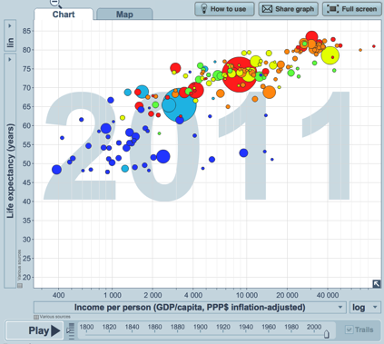
http://www.gapminder.org

Spend some time on their site creating various graphs. Choose some measures that interest you and discuss anomalies in the graph.

For example, you might compare life expectancy to income per person in a country. Your graph would look like this one: http://www.bit.ly/LGdzdR. Animate the graph. Choose something that stands out and research the reasons for the anomaly. In this example, you might research reasons for the sudden drop in life expectancy in Botswana.

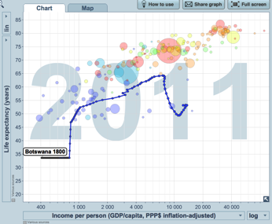
Your Task

Collect Data and Validate Sources
- Choose two measures to compare that interest you. Animate the graph and look for anomalies. Research and explain the anomalies.
Analyze and Present Data
- Analyze the data you have collected. Answer questions like (but not limited to): What caused the anomaly? Are there other factors that could have contributed to the change?
Present Multiple Sides
- Identify any controversies and present multiple sides of the issue with supporting data. For the anomaly you examined, what controversy surrounds the reason you identified for the anomaly?
Present Research Project
- Present your project in a format approved by your teacher.

Which Team is Better?

One of the great debates for sports fans is which team from which era is the best.

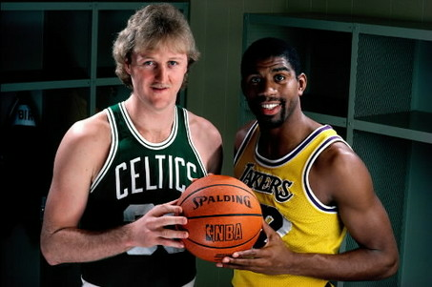
http://3.bp.blogspot.com/-q4ZbLGq2LRY/TzNJJbdXOxI/AAAAAAAADek/hL6uGxl2LZQ/s1600/magic-and-bird-II.jpg

Compare two teams. You might choose two teams from the same era, or two teams from different eras. Which team was better? Magic Johnson's Lakers, or Larry Bird's Celtics? The 1970 Montreal Canadiens dynasty, or the 1980's Edmonton Oiler dynasty? Your teams can be from any sport. You might even go across sports and look at which team was most dominant in its sport in a season.

Your Task

Collect Data and Validate Sources
- Collect data on the two teams you have chosen. You will need to determine what data is relevant to your conclusion.
Analyze and Present Data
- Analyze the data you have collected. Determine which team was better, based on the data you collected. Decide how to present this data to support your argument.
Present Multiple Sides
- Identify any controversies and present multiple sides of the issue with supporting data. What arguments would the other team use to claim they were better?
Present Research Project
- Present your project in a format approved by your teacher.

Paper Folding

It has long been rumored that it is impossible to fold a piece of paper more than 6 times.

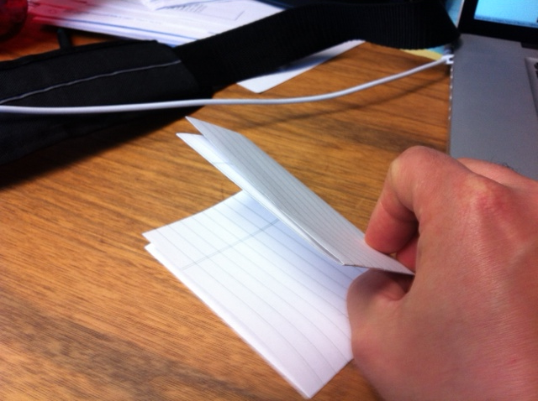

Explore the mathematics behind this rumor.

Your Task

Collect Data and Validate Sources
- Collect data showing the number of layers compared to the number of folds. What pattern emerges?
- If you generated the data yourself, how can you be sure it is accurate?
Analyze and Present Data
- Explore the math behind the pattern, and make some predictions. Answer questions like (but not limited to): Is it possible to fold a piece of paper more than 6 times? How many layers thick would a 7 fold paper be? How many folds would be required to reach the height of a common object like a desk or a counter? If it could be folded over and over again, how many folds would be required to reach the height of a tall building?
- Compare the number of folds to the heights of several objects. Be sure to show any calculations you make.
Present Multiple Sides
- Identify any controversies and present multiple sides of the issue with supporting data. The Myth Busters team tackled this one. Watch the video of their attempt on YouTube, and discuss whether or not they have debunked this myth. http://www.youtube.com/watch?v=kRAEBbotuIE
Present Research Project
- Present your project in a format approved by your teacher.

Student Planning Guide

Name _________________________________________________________________

Basic Expectations of a Research Project
- The topic is appropriate
- The sources are identified and evaluated
- The data is analyzed and interpreted

Planning Guide

This planning guide will help you organize and prepare your mathematics research project. It will help you meet all of the criteria required of this project.

Step 1 - Choosing an Appropriate Topic -
Choose a topic that involves mathematics and that is of interest to you. In the space below, briefly describe your topic and the mathematics involved. Share your topic with your teacher before beginning your research. Your teacher and/or your classmates can help you come up with an appropriate topic if you can't think of anything.

My Topic:

Mathematics Involved:

Step 2 - Conducting Your Research

You will need to find data related to your topic to analyze and interpret. This data may be informational or statistical in nature. You need to access your data from more than one source so that you can compare and evaluate the validity of the sources.

Where will you go to find the information/data you need? Is it readily available? Explain.

Once you have found the information/data, explain how you know the data is valid.

Student Planning Guide

Step 3 - Interpreting the Data

Interpret your data. It is possible that a mathematical interpretation of your data will require mathematics you haven't studied yet. If that is the case, please see your teacher for help. Mathematical calculations are not the focus of this research project. Your interpretation is what will be assessed.

How will you present your interpretation of this data? Some data might be displayed in a graph. Other data might be presented in a chart or by showing your calculations. Provide a brief description of your interpretation of the data below.

Did you encounter any controversies or multiple points of view in your research? If so, explain below what those are.

Step 4 - Preparing Your Presentation

You now have your topic, data, and an idea about how to interpret that data. Your next step is to prepare your presentation. You may wish to use:
- Prezi
- PowerPoint
- Poster
- Written Summary

Please check with your teacher as to what types of presentation will be acceptable in your class.

Describe below how you will present your findings. Then get to work building your presentation.

Your presentation must include:
- Your topic
- Your data
- An analysis of the validity of your data sources
- A description of the multiple points of view and controversies, if applicable
- An interpretation of your data including any predictions and conclusions you can reach

Rubric

Student _____________________________________ Date _____________________

Level  Criteria | Excellent | Proficient | Adequate | Limited * | Insufficient/ Blank *
Collect primary or secondary data related to the topic  (MRP 1)  [CN, V] | Collects data that is pertinent and conclusively establishes the trend. | Collects data that is relevant and substantially establishes the trend. | Collects data that is suitable and generally establishes the trend. | Collects data that is irrelevant and does little to establish the trend. | No score is awarded because there is insufficient evidence of student performance based on the requirements of the assessment task.
Interpret the Data  (MRP 1)  [ME, PS, R, V, T] | Provides an astute interpretation of the data. | Provides a credible interpretation of the data. | Provides a rudimentary interpretation of the data. | Provides a flawed interpretation of the data.
Present multiple sides of the issue with supporting data  (MRP 1)  [C, CN, R] | Presents multiple sides of issue with precise supporting data. | Presents multiple sides of issue with relevant supporting data. | Presents multiple sides of issue with basic supporting data. | Unable to present multiple sides, or presents multiple sides of issue with flawed supporting data.
Organize and present the research project  (MRP 1)  [C, CN] | Organizes and presents the research in a purposeful and compelling manner. | Organizes and presents the research in a logical and effective manner. | Organizes and presents the research in a reasonable and simplistic manner. | Organizes and presents the research in a disorganized and ineffective manner.

- When work is judged to be limited or insufficient, the teacher makes decisions about appropriate intervention to help the student improve.

